**Irish Modernism**

Modernism in Ireland was bound up with major social and political factors during the first part of the twentieth century, especially the effects of independence and Partition in 1922 and the role of the visual within national identity. This is an important context for Irish artists’ engagement with the wider development of European modernism; Cubism and Expressionism were particularly significant and, to a lesser extent, Surrealism. In 1910 the painters Paul and Grace Henry travelled from Dublin to Achill Island on Ireland’s Western seaboard, where they remained until the end of the First World War. This move, to some degree, emulated the earlier example of European avant-garde artists - such as Paul Gauguin in abandoning Paris for initially Brittany and then Tahiti - but it was also a sign of the fascination with the West that became an important cultural focus for an independent Ireland. The rural West, Catholic and Gaelic speaking, in many ways embodied the ideologies of the new Irish Free State. In addition to being the subject of Henry’s pastel-toned landscapes it became a major focus for both realist artists such as Seán Keating and modernist painters including Jack B. Yeats and Patrick Collins.

Paul Henry’s landscapes were derived from Whistler’s tonal harmonies; a far more radical approach was embodied in the work of Mainie Jellett and Evie Hone who introduced Cubism to Ireland at the Society of Dublin Painters exhibition in 1923. As protestant Anglo-Irish women, Jellett and Hone were from a class increasingly marginal to the concerns of the Free State. Their abstract paintings derived from collaboration with Albert Gleizes in Paris and, involving the application of Gleizes’ principles of translation and rotation to pictorial structure, represented a radical strangeness in comparison with the conservative social realism of Keating and others in the 1920s and 1930s. , However, the pervasiveness of images of the rural West and its peasantry in the emergent Free State was one reason why Cubism failed to become a significant force in Irish art practice.

Expressionist painting proved to be considerably more durable, particularly through the work of Jack B. Yeats, which, throughout his life, became increasingly concerned with the depiction of the West recalled from memory or mythology and far removed from the realism of other existing representations. Yeats generally used a loose expressionist brushstroke and increasingly abstract handling of paint that was highly influential on subsequent painters, such as Patrick Collins. For Nano Reid (1900-1981), however, expressionism was better used to depict landscapes less laden with national significance, localised in her native County Louth, North of Dublin. With Norah McGuinness, Reid was one of the two women artists who represented Ireland when the country participated for the first time in the Venice Biennale in 1950.

After 1922 artists in Northern Ireland increasingly benefited from closer connections with London. After studying at the Slade, the sculptor F.E. McWilliam remained in England, becoming active in the British Surrealist Group of the 1930s, and subsequently making a significant contribution to the development of British post-war figurative sculpture. The first encounter with modernist painting in Northern Ireland itself was also informed by a British example: the short-lived Ulster Unit (1934), including Colin Middleton and John Luke, derived its name from Unit One, then the main focus of British modernist innovation.

Surrealism was important for Northern Irish artists’ developing engagement with the politics of modernism. For McWilliam it allowed the articulation of anti-fascist protest far removed from Northern Ireland’s polarised sectarianism. In Northern Ireland itself, particularly during the Second World War, it also enabled artists such as Luke, Middleton or the English-born Nevill Johnson to develop a response to changing social and political conditions beyond the binaries of unionism or nationalism. Middleton, whose work embraced a plethora of avant-garde styles throughout his career, produced a number of Surrealist paintings in response to the Belfast Blitz.

Meanwhile, in Dublin, the Free State’s wartime neutrality attracted a number of mainly British émigré artists including Basil Rakoczi, founder of the White Stag Group, and his partner Kenneth Hall who arrived in Ireland in 1940. The White Stag Group, named after a Hungarian symbol of creativity, provided a focus for Dublin bohemia. The group also included the Irish artist Dairine Vanston who returned from France after the outbreak of war, and the English painter Stephen Gilbert later active in the CoBrA group. Paintings such as Rakoczi’s *Prisoner* (1944) suggested an awareness of wartime conditions often absent in Dublin at the time. The group helped to erode the insularity of art there and was a major factor in the instigation of the Irish Exhibition of Living Art in 1943 – the first major challenge to the power of academic art in Ireland – which included 168 works by 78 painters and sculptors.

During the postwar period, the main focus of innovation in Irish art shifted to outside Ireland itself. A significant number of Irish artists became active in the development of postwar British modernism, including not only F.E.McWilliam and Francis Bacon (born in Dublin), but also William Scott and Louis le Brocquy. A further group of London-based artists was focused around Gerard Dillon, a working-class painter from Belfast whose nostalgia-tinged depictions of the West of Ireland often contained a degree of homoeroticism. However, it was le Brocquy whose work had most impact in Ireland itself, continuing to engage with Irish cultural themes throughout his long career; his wife, Anne Madden, was also one of the first Irish artists to engage with the impact of American Abstract Expressionism.

In the 1960s, as elsewhere, modernism in Ireland was gradually superseded by other forms of art. As Ireland underwent increasing modernisation, the impact of American Pop Art became particularly important through the work of Micheal Farrell and Robert Ballagh; however, modernism still retained an influence for many years to come.

**References and Further Reading**:

Barber, F. (2013) *Irish Art since 1910,* London: Reaktion Books

Barber, F. (2005) ‘Excavating Room 50: Irish Art and the Cold War at the Venice Biennale’ in *A Shared Legacy: Essays on Irish and Scottish Art and Visual Culture,* ed. Fintan Cullen and John Morrison, Aldershot: Ashgate pp.207-223.

Coulter, R. (2008) ‘“An Amazing Anthology of Modern Art”: Place, Archetype and Identity in the Art of Colin Middleton’, *Visual Culture in Britain* IX/I*,* pp.1-25.

Coulter, R. (2009) ‘Nationalism, Homosexuality and the Modern Irish Artist’, *Eire-Ireland* 45, 3 and 4, Fall/Winter 2010, pp. 63-94.

Junquosa, E. and Kennedy, C. eds (2011) *The Moderns: the Arts in Ireland from the 1900s to the 1970s,* Dublin: Irish Museum of Modern Art.

Kennedy, S.B. (1991) *Irish Art and Modernism,* Belfast: Institute of Irish Studies.

Kennedy, S.B. (2000) *Paul Henry,* New Haven and London: Yale University Press.

Kissane, S. ed. (2005) *The White Stag Group,* Dublin: Irish Museum of Modern Art.

**Images**

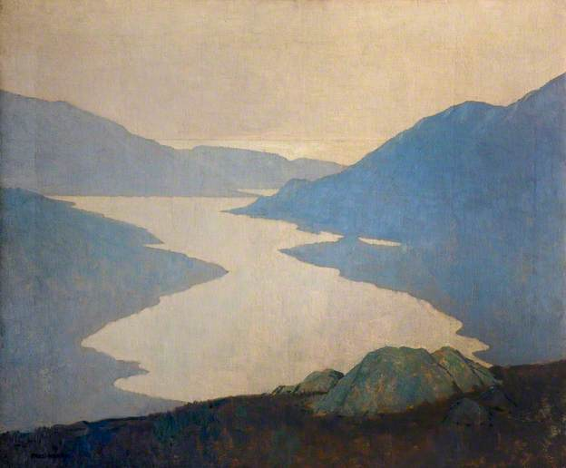

Paul Henry *Dawn, Killary Harbour* 1921 <http://www.bbc.co.uk/arts/yourpaintings/paintings/dawn-killary-harbour-117814>

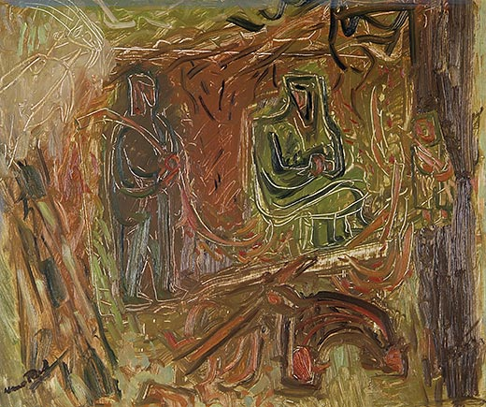

Nano Reid, *Tinkers Gathering Firewood* 1950 <http://www.crawfordartgallery.ie/pages/paintings/NanoReid.html>

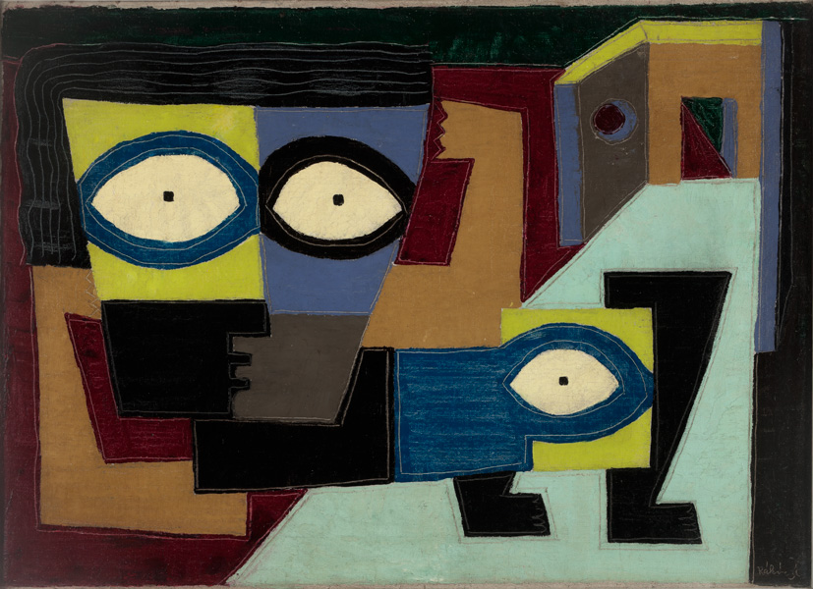

Basil Rakoczi *The* *Prisoner* 1944

<http://imma.gallery-access.com/intl/en/tour.php?a_id=23>

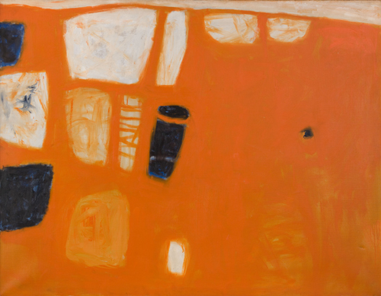

William Scott *Orange and Blue* 1950

<http://williamscott.org/works/1950/orange-and-blue>

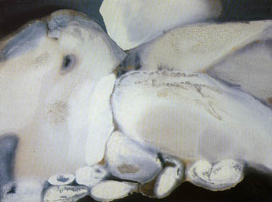

Anne Madden, *Land Near Kilnaboy* 1964

<http://www.anne-madden.com/MaddenPages/painting13.html>